UPON THE DRYING BEHAVIOR OF TURKEY OAK LUMBER

Iulia DEACONU¹, Mihaela CAMPEAN^{1,*}, Maria IONESCU²
¹Transilvania University of Brasov, Romania
²Research Institute, Sibiu, Romania

*Corresponding author: campean@unitbv.ro

The paper presents the results of an experimental research performed with 50-mm thick Turkey oak (Quercus cerris L.) lumber boards. The research mainly envisaged the determination of the drying rate and of the drying quality as function of the drying conditions.
Half of the boards were air-dried for 7 months (November-June), and half were kiln-dried from green state. Half of the kiln-dried samples were steamed previous to drying. After drying, all boards were subjected to a quality control procedure, where the uniformity of the final moisture content, the casehardening degree, the occurrence of cracks, deformations and colorations was evaluated.
Better results in terms of the drying quality were obtained for the kiln-dried boards. The air-drying allowed only a reduction from 53% to 44% of the moisture content, and all boards suffered deterioration. The kiln-drying allowed the reduction of the moisture content from 53% to 12% in 210 days. Only 10% of the kiln-dried boards displayed cracks (surface cracks). None of the steamed board suffered any deterioration. The most important issue with the 50mm thick lumber is the moisture gradient across the lumber thickness, which is high (10-18%) from the beginning of the process. Turkey oak is very sensitive to temperature, so as soon as the temperature rises (even under natural conditions, when shifting from winter to spring), if the air humidity is not high enough, the lumber will crack. By riguros control of the air humidity, kiln-drying creates better conditions to keep the inner stresses under control.
Based on the obtained results, a recommendation regarding optimum drying conditions was formulated for the industry.
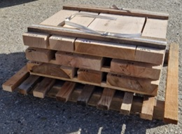 | 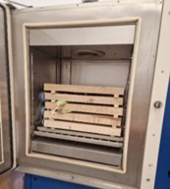
Mini-stacks of 50-mm thick Turkey oak lumber boards subjected to air-drying and kiln-drying

